UNITED STATES

SECURITIES AND EXCHANGE COMMISSION

WASHINGTON, D.C. 20549
FORM 8-K
CURRENT REPORT
Pursuant to Section 13 or 15(d) of the Securities Exchange Act of 1934
Date of Report (Date of Earliest Event Reported): |  |  | May 14, 2026

INNOVATE CORP.
(Exact name of registrant as specified in its charter)
Delaware |  |  | 001-35210 |  |  | 54-1708481
(State or other jurisdiction of incorporation) |  |  | (Commission File Number) |  |  | (I.R.S. Employer Identification No.)
295 Madison Ave., 12th Floor |  |  |  |  |  | 10017
New York, NY
(Address of principal executive offices) |  |  |  |  |  | (Zip Code)

Registrant’s telephone number, including area code: |  |  |  |  |  | (212) 235-2691

Check the appropriate box below if the Form 8-K filing is intended to simultaneously satisfy the filing obligation of the registrant under any of the following provisions (see General Instruction A.2. below):
☐ |  |  | Written communications pursuant to Rule 425 under the Securities Act (17 CFR 230.425)
☐ |  |  | Soliciting material pursuant to Rule 14a-12 under the Exchange Act (17 CFR 240.14a-12)
☐ |  |  | Pre-commencement communications pursuant to Rule 14d-2(b) under the Exchange Act (17 CFR 240.14d-2(b))
☐ |  |  | Pre-commencement communications pursuant to Rule 13e-4(c) under the Exchange Act (17 CFR 240.13e-4(c))

Securities registered pursuant to Section 12(b) of the Act:
Title of each class |  |  | Trading Symbol |  |  | Name of each exchange on which registered
Common Stock, par value $0.001 per share |  |  | VATE |  |  | New York Stock Exchange
Preferred Stock Purchase Rights |  |  | N/A |  |  | New York Stock Exchange

Indicate by check mark whether the registrant is an emerging growth company as defined in as defined in Rule 405 of the Securities Act of 1933 (§230.405 of this chapter) or Rule 12b-2 of the Securities Exchange Act of 1934 (§240.12b-2 of this chapter).
Emerging growth company |  |  | ☐
If an emerging growth company, indicate by check mark if the registrant has elected not to use the extended transition period for complying with any new or revised financial accounting standards provided pursuant to Section 13(a) of the Exchange Act. |  |  | ☐

Item 2.02 Results of Operations and Financial Condition

On May 14, 2026, INNOVATE Corp. (the “Company”) issued a press release announcing its results for the three months ended March 31, 2026 (the “Earnings Release”) and posted the INNOVATE Corp. First Quarter 2026 Conference Call Investor Presentation to its Investor Relations section of the Company’s website at http://www.innovatecorp.com.

A copy of the Earnings Release and the investor presentation are attached hereto as Exhibits 99.1 and 99.2, respectively, and are incorporated herein by reference.

Item 7.01 Regulation FD Disclosure

As previously announced, the Company will conduct a conference call today, Thursday, May 14, 2026, at 4:30 p.m. ET. The presentation slides to be used during the call, attached hereto as Exhibit 99.2, will be available on the “Investor Relations” section of the Company’s website (http://www.innovatecorp.com) immediately prior to the call. The conference call and the presentation slides will be simultaneously webcast on the “Investor Relations” section of the Company’s website beginning at 4:30 p.m. ET on Thursday, May 14, 2026. The information contained in, or that can be accessed through the Company’s website is not a part of this filing.

The information in Item 2.02 and Item 7.01 of this Current Report on Form 8-K, including Exhibits 99.1 and 99.2, is being furnished and shall not be deemed “filed” for purposes of Section 18 of the Securities Exchange Act of 1934, as amended (the “Exchange Act”), or otherwise subject to the liabilities of that Section, nor shall it be deemed incorporated by reference into any of the Company’s filings under the Securities Act of 1933, as amended, or the Exchange Act, whether made before or after the date hereof and regardless of any general incorporation language in such filings, except to the extent expressly set forth by specific reference in such a filing.

Item 9.01 Financial Statements and Exhibits

(d) Exhibits

Exhibit  No. |  |  | Description
99.1 |  |  | Press Release of INNOVATE Corp., dated May 14, 2026
99.2 |  |  | INNOVATE Corp. First Quarter 2026 Conference Call Investor Presentation
104 |  |  | Cover Page Interactive Data File (formatted as Inline XBRL and contained in Exhibit 101).

SIGNATURES

Pursuant to the requirements of the Securities Exchange Act of 1934, the registrant has duly caused this report to be signed on its behalf by the undersigned hereunto duly authorized.

 |  |  | INNOVATE Corp.
May 14, 2026 |  |  | By: |  |  | /s/ Michael J. Sena
 |  |  |  |  |  | Name: Michael J. Sena
 |  |  |  |  |  | Title: Chief Financial Officer



FOR IMMEDIATE RELEASE
INNOVATE Corp. Announces First Quarter 2026 Results
- Infrastructure: Strong first quarter results with revenue of $357.9 million
- Life Sciences: MediBeacon receives the CE mark for the Transdermal GFR Monitor and Reusable Sensor
- Spectrum: More than 60 new license applications filed to expand national footprint and increase population coverage
NEW YORK, NY, May 14, 2026 - INNOVATE Corp. (“INNOVATE” or the “Company”) (NYSE: VATE) announced today its consolidated results for the first quarter.
Financial Summary
(in millions, except per share amounts) |  |  | Three Months Ended March 31,
 |  |  | 2026 |  |  |  |  |  | 2025 |  |  |  |  |  | Increase / (Decrease)
Revenue |  |  | $ | 364.8 |  |  |  |  | $ | 274.2 |  |  |  |  | 33.0 |  | %
Net loss attributable to common stockholders and participating preferred stockholders |  |  | $ | (17.2) |  |  |  |  | $ | (24.8) |  |  |  |  | 30.6 |  | %
Basic and Diluted loss per share attributable to common stockholders |  |  | $ | (1.29) |  |  |  |  | $ | (1.89) |  |  |  |  | 31.7 |  | %
Total Adjusted EBITDA(1) |  |  | $ | 19.7 |  |  |  |  | $ | 7.2 |  |  |  |  | 173.6 |  | %
(1) Reconciliation of GAAP to Non-GAAP measures follows

Commentary

"INNOVATE delivered a strong start to the year, with solid execution and improving visibility across the portfolio,” said Avie Glazer, Chairman of INNOVATE. “Infrastructure performed well in the first quarter, supported by healthy sales performance, strong backlog and pipeline, and continued opportunities in the technology-related construction markets that are concentrated around AI infrastructure, energy systems, advanced manufacturing, and digital connectivity. In Life Sciences, MediBeacon received CE mark approval for the Transdermal GFR Monitor and Reusable Sensor in Europe, while R2 continued to expand internationally. We also made progress in Spectrum through successful collaborative trials, supporting potential market launches in the second half of 2026."

"We continue to advance our strategic priorities and strengthen the foundation of the Company,” said Paul Voigt, Interim CEO of INNOVATE. “DBM Global exited the quarter with strong momentum, supported by a robust pipeline and early progress building 2027 backlog, reinforcing confidence in sustained revenue and potential upside. In Life Sciences, MediBeacon achieved key regulatory and commercial milestones, including CE Mark approval of the Transdermal GFR Monitor and Reusable Sensor in Europe and growing momentum with key academic medical centers, while R2 continued to expand internationally. At Spectrum, despite near-term advertising pressures, we are encouraged by progress on strategic opportunities that position the business for improved performance in 2026."

1
First Quarter 2026 and Recent Highlights
Infrastructure
•DBM Global Inc. ("DBMG") reported first quarter 2026 revenue of $357.9 million, an increase of 35.1%, compared to $264.9 million in the prior year quarter. Net income attributable to INNOVATE was $9.3 million, compared to $4.6 million for the prior year quarter. Adjusted EBITDA increased to $23.0 million from $16.7 million in the prior year quarter.
•DBMG reported gross margin of 14.2% in the first quarter, a compression of approximately 140 basis points year-over-year and Adjusted EBITDA margin of 6.4% in the first quarter, largely consistent with the prior year quarter.
•DBMG’s reported backlog and adjusted backlog, which takes into consideration awarded but not yet signed contracts, was $1.6 billion and $1.8 billion respectively, as of March 31, 2026, compared to reported and adjusted backlog of $1.7 billion and $1.8 billion, respectively, as of December 31, 2025.
•DBMG delivered a strong first quarter with healthy sales execution, high conversion across active pursuits, and solid backlog visibility supporting the 2026 plan; momentum exiting the quarter, a robust and improving pipeline, and early progress building 2027 backlog underpin confidence in sustained revenue durability and potential upside, with focus now shifting from near-term execution to disciplined capacity-aligned growth.
Life Sciences
•MediBeacon received the CE mark under European Medical Device Regulation for the Transdermal GFR ("TGFRTM") Monitor and TGFRTM Reusable Sensor.
•MediBeacon is building momentum in the United States with key academic medical centers who are beginning to bring the TGFR System into the clinic as part of the MediBeacon Centers of Excellence early access program.
•R2 Technologies, Inc. ("R2") reported first quarter 2026 revenue of $1.6 million.
•R2's demand for the first quarter reached $2.2 million, with backlog increasing to nearly 160 systems globally post quarter end.
•R2 's gross system sales outside North America increased 58.6% over the prior year quarter, reflecting strong demand for R2's technology across international markets.
Spectrum
•Broadcasting reported first quarter 2026 revenue of $5.3 million, compared to $6.2 million in the prior year quarter. Net loss attributable to INNOVATE was $6.5 million compared to $5.4 million in the prior year quarter. Adjusted EBITDA was $0.7 million, compared to $1.4 million in the prior year quarter.
•First quarter results reflect continued softness in advertising and network cancellations.
•Collaborative project underway with major mobile wireless carrier continues with successful trials and prospective funding for new market launches in the second half of 2026.
•March petition filed with the FCC proposing 5G Broadcast conversions for Low Power TV continues to gain support, but still waiting for FCC approvals.

First Quarter 2026 Financial Highlights
•Revenue: For the first quarter of 2026, INNOVATE's consolidated revenue was $364.8 million, an increase of 33.0%, compared to $274.2 million for the prior year quarter. The increase was driven primarily by our Infrastructure segment, which was partially offset by decreases at our Life Sciences and Spectrum segments. The increase at our Infrastructure segment was primarily driven by the timing and size of projects at DBMG's commercial structural steel fabrication and erection business, which had increased activity subsequent to the comparable period on certain large construction projects. This increase was partially offset by a decrease at the industrial maintenance and repair business due to the timing and size of projects, which had
2
increased activity in the comparable period on certain large construction projects that have since been completed. The decrease at our Life Sciences segment was attributable to R2, primarily driven by decreases in Glacial fx and Glacial Rx unit sales in North America, which were partially offset by an increase in Glacial Spa unit sales outside North America. The decrease at our Spectrum segment was primarily driven by the termination of a few networks and individual markets subsequent to the comparable period.
REVENUE by OPERATING SEGMENT
(in millions) |  |  | Three Months Ended March 31,
 |  |  | 2026 |  |  |  |  |  | 2025 |  |  |  |  |  | Increase / (Decrease)
Infrastructure |  |  | $ | 357.9 |  |  |  |  | $ | 264.9 |  |  |  |  | $ | 93.0
Life Sciences |  |  | 1.6 |  |  |  |  |  | 3.1 |  |  |  |  |  | (1.5)
Spectrum |  |  | 5.3 |  |  |  |  |  | 6.2 |  |  |  |  |  | (0.9)
Consolidated INNOVATE |  |  | $ | 364.8 |  |  |  |  | $ | 274.2 |  |  |  |  | $ | 90.6

•Net Loss: For the first quarter of 2026, INNOVATE reported a Net loss attributable to common stockholders and participating preferred stockholders of $17.2 million, or $1.29 per fully diluted share, compared to $24.8 million, or $1.89 per fully diluted share, for the prior year quarter. The decrease in Net loss was primarily driven by a net increase in gross profit of $8.0 million, a decrease in loss from equity investees of $5.9 million and a $4.2 million decrease in tax expense, which was partially offset by a $4.3 million increase in interest expense, a $3.7 million decrease in other income, net and a net increase in selling, and general and administrative (“SG&A”) expenses of $1.6 million. The net increase in gross profit was primarily driven by our Infrastructure segment due to timing and size of projects in the current period, which had increased activity subsequent to the comparable period, which was partially offset by our Spectrum and Life Sciences segments due to the decreases in revenue. The decrease in loss from equity investees was due to a decrease in losses recognized from MediBeacon primarily as a result of unrepeated equity changes that resulted from the milestone payments received from Huadong following FDA approval in the comparable period. The decrease in tax expense was primarily driven by the impact of projected pre-tax results on the annual effective tax rate including as limitations on the utilization of net operating losses (“NOL”) by INNOVATE's U.S. consolidated group as a result of the Internal Revenue Code Section 382 and the Tax Cuts and Jobs Act's 80 percent limitation on NOLs incurred after 2017. The net increase in interest expense was primarily driven by our Non-Operating Corporate segment, partially offset by our Life Sciences segment, mainly due to the refinancing transactions that closed subsequent to the comparable period. The decrease in other income, net, was primarily driven by the unrepeated step-up gain following MediBeacon's FDA approval in the comparable period. The net increase in SG&A was primarily driven by our Infrastructure segment, primarily due to an increase in compensation-related expenses due to timing, as well as an increase at our Non-Operating Corporate segment primarily driven by expenses in the current period related to potential dispositions. These increases in SG&A were partially offset by a decrease in SG&A at our Life Sciences segment due to a reduction in compensation-related expenses at R2 and Pansend.
3
NET INCOME (LOSS) by OPERATING SEGMENT
(in millions) |  |  | Three Months Ended March 31,
 |  |  | 2026 |  |  |  |  |  | 2025 |  |  |  |  |  | Increase / (Decrease)
Infrastructure |  |  | $ | 9.3 |  |  |  |  | $ | 4.6 |  |  |  |  | $ | 4.7
Life Sciences |  |  | (3.3) |  |  |  |  |  | (7.6) |  |  |  |  |  | 4.3
Spectrum |  |  | (6.5) |  |  |  |  |  | (5.4) |  |  |  |  |  | (1.1)
Non-Operating Corporate |  |  | (16.3) |  |  |  |  |  | (16.1) |  |  |  |  |  | (0.2)
Other and eliminations |  |  | — |  |  |  |  |  | — |  |  |  |  |  | —
Net loss attributable to INNOVATE Corp. |  |  | $ | (16.8) |  |  |  |  | $ | (24.5) |  |  |  |  | 7.7
Less: Preferred stock dividends |  |  | 0.4 |  |  |  |  |  | 0.3 |  |  |  |  |  | 0.1
Net loss attributable to common stockholders and participating preferred stockholders |  |  | $ | (17.2) |  |  |  |  | $ | (24.8) |  |  |  |  | $ | 7.6

•Adjusted EBITDA: For the first quarter of 2026, Total Adjusted EBITDA was $19.7 million compared to Total Adjusted EBITDA of $7.2 million for the prior year quarter. The increase in Adjusted EBITDA was primarily driven by our Life Sciences and Infrastructure segments, which was partially offset by a decrease at our Spectrum segment. The increase at our Life Sciences segment was primarily driven by fewer equity method losses recognized from MediBeacon and a decrease in recurring SG&A due to a reduction in compensation-related expenses at R2 and Pansend, which was partially offset by a decrease in gross profit at R2 due to the decrease in revenue. The increase at our Infrastructure segment was primarily driven by an increase in gross profit at DBMG's commercial structural steel fabrication and erection business which had increased activity subsequent to the comparable period on certain large construction projects. The increase was partially offset by a decrease in revenue and gross profit at our industrial maintenance and repair business due to timing of certain large construction projects in the comparable period that have since been completed and an increase in recurring SG&A expenses, primarily driven by an increase in compensation-related expenses due to timing. The decrease in Adjusted EBITDA at our Spectrum segment was primarily driven by the decrease in revenue.
ADJUSTED EBITDA by OPERATING SEGMENT
(in millions) |  |  | Three Months Ended March 31,
 |  |  | 2026 |  |  |  |  |  | 2025 |  |  |  |  |  | Increase / (Decrease)
Infrastructure |  |  | $ | 23.0 |  |  |  |  | $ | 16.7 |  |  |  |  | $ | 6.3
Life Sciences |  |  | (2.0) |  |  |  |  |  | (8.7) |  |  |  |  |  | 6.7
Spectrum |  |  | 0.7 |  |  |  |  |  | 1.4 |  |  |  |  |  | (0.7)
Non-Operating Corporate |  |  | (2.0) |  |  |  |  |  | (2.2) |  |  |  |  |  | 0.2
Other and eliminations |  |  | — |  |  |  |  |  | — |  |  |  |  |  | —
Total Adjusted EBITDA |  |  | $ | 19.7 |  |  |  |  | $ | 7.2 |  |  |  |  | $ | 12.5

•Balance Sheet: As of March 31, 2026, INNOVATE had cash and cash equivalents, excluding restricted cash, of $134.6 million compared to $112.1 million as of December 31, 2025. On a stand-alone basis, as of March 31, 2026, our Non-Operating Corporate segment had cash and cash equivalents of $2.5 million compared to $4.2 million as of December 31, 2025.

4
Conference Call
INNOVATE will host a live conference call to discuss its first quarter 2026 financial results and operations today at 4:30 p.m. ET. The Company will post an earnings supplemental presentation in the Investor Relations section of the INNOVATE website at innovate-ir.com to accompany the conference call. Dial-in instructions for the conference call and the replay follows.
•Live Webcast and Call. A live webcast of the conference call can be accessed by interested parties through the Investor Relations section of the INNOVATE website at innovate-ir.com.
–Dial-in: 1-877-704-4453 (Domestic Toll Free) / 1-201-389-0920 (Toll/International)
•Conference Replay*
–Dial-in: 1-844-512-2921 (Domestic Toll Free) / 1-412-317-6671 (Toll/International)
–Conference Number: 13760214
*Available approximately three hours after the end of the conference call through May 28, 2026.

About INNOVATE
INNOVATE is a portfolio of best-in-class assets in three key areas of the new economy – Infrastructure, Life Sciences and Spectrum. Dedicated to stakeholder capitalism, INNOVATE employs approximately 3,700 people across its subsidiaries. For more information, please visit: www.INNOVATECorp.com.

Contacts

Investor Contact:
Anthony Rozmus
ir@innovatecorp.com
(212) 235-2691

Non-GAAP Financial Measures
In this press release, INNOVATE refers to certain financial measures that are not presented in accordance with U.S. generally accepted accounting principles (“U.S. GAAP”), including Total Adjusted EBITDA (excluding discontinued operations, if applicable) and Adjusted EBITDA for its operating segments. In addition, other companies may define Adjusted EBITDA differently than we do, which could limit its usefulness.
Adjusted EBITDA
Management believes that Adjusted EBITDA provides investors with meaningful information for gaining an understanding of our results as it is frequently used by the financial community to provide insight into an organization’s operating trends and facilitates comparisons between peer companies, since interest, taxes, depreciation, amortization and the other items listed in the definition of Adjusted EBITDA below can differ greatly between organizations as a result of differing capital structures and tax strategies. Adjusted EBITDA can also be a useful measure of a company’s ability to service debt. While management believes that non-U.S. GAAP measurements are useful supplemental information, such adjusted results are not intended to replace our U.S. GAAP financial results. Using Adjusted EBITDA as a performance measure has inherent limitations as an analytical tool as compared to net income (loss) or other U.S. GAAP financial measures, as this non-U.S. GAAP measure excludes certain items, including items
5
that are recurring in nature, which may be meaningful to investors. As a result of the exclusions, Adjusted EBITDA should not be considered in isolation and does not purport to be an alternative to net income (loss) or other U.S. GAAP financial measures as a measure of our operating performance.

The calculation of Adjusted EBITDA, as defined by us, consists of Net income (loss) attributable to INNOVATE Corp., excluding: discontinued operations, if applicable; depreciation and amortization; other operating (income) loss (which is inclusive of (gain) loss on sale or disposal of assets, lease termination costs, (gains) losses on lease modifications, and asset impairment expense); interest expense; other (income) expense, net; income tax expense (benefit); non-controlling interests; share-based compensation expense; realignment and exit costs; facility commissioning costs and acquisition and disposition costs.
Cautionary Statement Regarding Forward-Looking Statements
Safe Harbor Statement under the Private Securities Litigation Reform Act of 1995: This press release contains, and certain oral statements made by our representatives from time to time may contain, “forward-looking statements.” Generally, forward-looking statements include information describing actions, events, results, strategies and expectations and are generally identifiable by use of the words “believes,” “expects,” “intends,” “anticipates,” “plans,” “seeks,” “estimates,” “projects,” “may,” “will,” “could,” “might,” or “continues” or similar expressions. Such forward-looking statements are based on current expectations and inherently involve certain risks, assumptions and uncertainties. The forward-looking statements in this press release include, without limitation, any statements regarding INNOVATE’s plans and expectations for future growth and ability to capitalize on potential opportunities, the achievement of INNOVATE’s strategic objectives, expectations for performance of new projects and realization of revenue from the backlog at DBMG and the Infrastructure segment, anticipated success from the continued sale of new products in the Life Sciences segment, expectations for advertising revenue growth, new technologies, networks and stations, and potential commercial opportunities in datacasting in the Spectrum segment. Such statements are based on the beliefs and assumptions of INNOVATE’s management and the management of INNOVATE’s subsidiaries and portfolio companies.

The Company believes these judgments are reasonable, but these statements are not guarantees of performance, results or the creation of stockholder value and the Company’s actual results could differ materially from those expressed or implied in the forward-looking statements due to a variety of important factors, both positive and negative, including those that may be identified in subsequent statements and reports filed with the Securities and Exchange Commission (“SEC”), including in our reports on Forms 10-K, 10-Q, and 8-K. Such important factors include, without limitation: our dependence on distributions from our subsidiaries to fund our operations and payments on our obligations; our ability to continue operating as a going concern; our expectations and timing with respect to any strategic dispositions and sales of our operating subsidiaries, or businesses, including, without limitation, the sales of DBMG and HC2 Broadcasting Holdings Inc.; the possibility of indemnification claims arising out of divestitures of businesses; the impact on our business and financial condition of our substantial indebtedness and any significant additional indebtedness and other financing obligations we may incur; our possible inability to raise additional capital when needed or refinance our existing debt, on attractive terms, or at all; our dependence on the retaining and recruitment of key personnel; volatility in the trading price of our common stock; the impact of potential supply chain disruptions, labor shortages and increases in overall price levels, including in steel and transportation costs; interest rate environment; developments relating to the hostilities in Ukraine, the Middle East and Venezuela; increased competition in the markets in which our operating segments conduct their businesses; our ability to successfully identify any strategic acquisitions or business opportunities; uncertain global economic conditions in the markets in which our operating segments conduct their businesses; changes in regulations and tax laws; covenant
6
noncompliance risk; tax consequences associated with our acquisitions, holding and disposition of target companies and assets; the ability of our operating segments to attract and retain customers; and our expectations regarding the timing, extent and effectiveness of any cost reduction initiatives and management’s ability to moderate or control discretionary spending.
Although INNOVATE believes its expectations and assumptions regarding its future operating performance are reasonable, there can be no assurance that the expectations reflected herein will be achieved. These risks and other important factors discussed under the caption “Risk Factors” in our most recent Annual Report on Form 10-K filed with the SEC, and our other reports filed with the SEC could cause actual results to differ materially from those indicated by the forward-looking statements made in this press release.

You should not place undue reliance on forward-looking statements. All forward-looking statements attributable to INNOVATE or persons acting on its behalf are expressly qualified in their entirety by the foregoing cautionary statements. All such statements speak only as of the date made, and unless legally required, INNOVATE undertakes no obligation to update or revise publicly any forward-looking statements, whether as a result of new information, future events or otherwise.

7
INNOVATE CORP.
CONDENSED CONSOLIDATED STATEMENTS OF OPERATIONS
(Unaudited, in millions, except shares and per share amounts)

 |  |  |  |  |  | Three Months Ended March 31,
 |  |  |  |  |  | 2026 |  |  |  |  |  | 2025
Revenue |  |  |  |  |  | $ | 364.8 |  |  |  |  | $ | 274.2
Cost of revenue |  |  |  |  |  | 311.3 |  |  |  |  |  | 228.7
Gross profit |  |  |  |  |  | 53.5 |  |  |  |  |  | 45.5
Operating expenses:
Selling, general and administrative |  |  |  |  |  | 39.4 |  |  |  |  |  | 37.8
Depreciation and amortization |  |  |  |  |  | 4.2 |  |  |  |  |  | 4.4
Other operating income |  |  |  |  |  | (0.1) |  |  |  |  |  | (0.1)
Income from operations |  |  |  |  |  | 10.0 |  |  |  |  |  | 3.4
Other (expense) income:
Interest expense |  |  |  |  |  | (24.5) |  |  |  |  |  | (20.2)
Loss from equity investees |  |  |  |  |  | — |  |  |  |  |  | (5.9)
Other income, net |  |  |  |  |  | 0.3 |  |  |  |  |  | 4.0
Loss from operations before income taxes |  |  |  |  |  | (14.2) |  |  |  |  |  | (18.7)
Income tax expense |  |  |  |  |  | (2.9) |  |  |  |  |  | (7.1)
Net loss |  |  |  |  |  | (17.1) |  |  |  |  |  | (25.8)
Net loss attributable to non-controlling interests and redeemable non-controlling interests |  |  |  |  |  | 0.3 |  |  |  |  |  | 1.3
Net loss attributable to INNOVATE Corp. |  |  |  |  |  | (16.8) |  |  |  |  |  | (24.5)
Less: Preferred stock dividends |  |  |  |  |  | 0.4 |  |  |  |  |  | 0.3
Net loss attributable to common stockholders and participating preferred stockholders |  |  |  |  |  | $ | (17.2) |  |  |  |  | $ | (24.8)
Loss per common share - basic and diluted |  |  |  |  |  | $ | (1.29) |  |  |  |  | $ | (1.89)
Weighted-average common shares outstanding - basic and diluted |  |  |  |  |  | 13,344,976 |  |  |  |  |  | 13,114,804

8
INNOVATE CORP.
CONDENSED CONSOLIDATED BALANCE SHEETS
(Unaudited, in millions, except share amounts)

 |  |  |  |  |  | March 31,  2026 |  |  |  |  |  | December 31,  2025
Assets
Current assets
Cash and cash equivalents |  |  |  |  |  | $ | 134.6 |  |  |  |  | $ | 112.1
Accounts receivable, net |  |  |  |  |  | 186.0 |  |  |  |  |  | 241.1
Contract assets |  |  |  |  |  | 54.5 |  |  |  |  |  | 64.1
Inventory |  |  |  |  |  | 15.4 |  |  |  |  |  | 16.0
Other current assets |  |  |  |  |  | 15.4 |  |  |  |  |  | 18.2
Total current assets |  |  |  |  |  | 405.9 |  |  |  |  |  | 451.5
Investments |  |  |  |  |  | 1.8 |  |  |  |  |  | 1.8
Deferred tax asset |  |  |  |  |  | 2.0 |  |  |  |  |  | 2.0
Property, plant and equipment, net |  |  |  |  |  | 148.1 |  |  |  |  |  | 141.8
Goodwill |  |  |  |  |  | 127.1 |  |  |  |  |  | 127.0
Intangibles, net |  |  |  |  |  | 163.7 |  |  |  |  |  | 165.2
Other assets |  |  |  |  |  | 88.2 |  |  |  |  |  | 60.8
Total assets |  |  |  |  |  | $ | 936.8 |  |  |  |  | $ | 950.1
Liabilities, temporary equity and stockholders’ deficit
Current liabilities
Accounts payable |  |  |  |  |  | $ | 130.2 |  |  |  |  | $ | 141.4
Accrued liabilities |  |  |  |  |  | 103.7 |  |  |  |  |  | 122.5
Current portion of debt obligations |  |  |  |  |  | 610.8 |  |  |  |  |  | 581.4
Contract liabilities |  |  |  |  |  | 157.3 |  |  |  |  |  | 171.9
Other current liabilities |  |  |  |  |  | 17.8 |  |  |  |  |  | 16.9
Total current liabilities |  |  |  |  |  | 1,019.8 |  |  |  |  |  | 1,034.1
Deferred tax liability |  |  |  |  |  | 4.7 |  |  |  |  |  | 4.7
Debt obligations |  |  |  |  |  | 68.8 |  |  |  |  |  | 80.3
Other liabilities |  |  |  |  |  | 75.7 |  |  |  |  |  | 46.3
Total liabilities |  |  |  |  |  | 1,169.0 |  |  |  |  |  | 1,165.4
Commitments and contingencies
Temporary equity
Preferred Stock Series A-3 and Preferred Stock Series A-4, $0.001 par value |  |  |  |  |  | 9.5 |  |  |  |  |  | 9.3
Shares authorized: 20,000,000; Shares issued and outstanding: 6,125 of Series A-3; 1,937 of Series A-4
Redeemable non-controlling interests |  |  |  |  |  | 1.3 |  |  |  |  |  | 1.6
Total temporary equity |  |  |  |  |  | 10.8 |  |  |  |  |  | 10.9
Stockholders’ deficit
Common stock, $0.001 par value |  |  |  |  |  | — |  |  |  |  |  | —
Shares authorized: 250,000,000; Shares issued: 13,818,904; Shares outstanding: 13,641,866 and 13,655,062, respectively
Additional paid-in capital |  |  |  |  |  | 350.4 |  |  |  |  |  | 350.1
Treasury stock, at cost: 177,038 and 163,842 shares, respectively |  |  |  |  |  | (5.6) |  |  |  |  |  | (5.6)
Accumulated deficit |  |  |  |  |  | (599.3) |  |  |  |  |  | (582.5)
Accumulated other comprehensive loss |  |  |  |  |  | (1.8) |  |  |  |  |  | (2.1)
Total INNOVATE Corp. stockholders’ deficit |  |  |  |  |  | (256.3) |  |  |  |  |  | (240.1)
Non-controlling interests |  |  |  |  |  | 13.3 |  |  |  |  |  | 13.9
Total stockholders’ deficit |  |  |  |  |  | (243.0) |  |  |  |  |  | (226.2)
Total liabilities, temporary equity and stockholders’ deficit |  |  |  |  |  | $ | 936.8 |  |  |  |  | $ | 950.1

9
INNOVATE CORP.
RECONCILIATION OF NET INCOME (LOSS) TO ADJUSTED EBITDA
(Unaudited, in millions)

(in millions) |  |  |  |  |  | Three Months Ended March 31, 2026
 |  |  |  |  |  | Infrastructure |  |  |  |  |  | Life Sciences |  |  |  |  |  | Spectrum |  |  |  |  |  | Non-Operating Corporate |  |  |  |  |  | Other and Eliminations |  |  |  |  |  | INNOVATE
Net income (loss) attributable to INNOVATE Corp. |  |  |  |  |  | $ | 9.3 |  |  |  |  | $ | (3.3) |  |  |  |  | $ | (6.5) |  |  |  |  | $ | (16.3) |  |  |  |  | $ | — |  |  |  |  | $ | (16.8)
Adjustments to reconcile net income (loss) to Adjusted EBITDA:
Depreciation and amortization |  |  |  |  |  | 2.9 |  |  |  |  |  | 0.1 |  |  |  |  |  | 1.2 |  |  |  |  |  | — |  |  |  |  |  | — |  |  |  |  |  | 4.2
Depreciation and amortization (included in cost of revenue) |  |  |  |  |  | 3.2 |  |  |  |  |  | — |  |  |  |  |  | — |  |  |  |  |  | — |  |  |  |  |  | — |  |  |  |  |  | 3.2
Other operating income |  |  |  |  |  | — |  |  |  |  |  | — |  |  |  |  |  | (0.1) |  |  |  |  |  | — |  |  |  |  |  | — |  |  |  |  |  | (0.1)
Interest expense |  |  |  |  |  | 1.8 |  |  |  |  |  | 1.9 |  |  |  |  |  | 4.0 |  |  |  |  |  | 16.8 |  |  |  |  |  | — |  |  |  |  |  | 24.5
Other (income) expense, net |  |  |  |  |  | (0.1) |  |  |  |  |  | — |  |  |  |  |  | 2.5 |  |  |  |  |  | (2.7) |  |  |  |  |  | — |  |  |  |  |  | (0.3)
Income tax expense (benefit) |  |  |  |  |  | 4.1 |  |  |  |  |  | — |  |  |  |  |  | — |  |  |  |  |  | (1.2) |  |  |  |  |  | — |  |  |  |  |  | 2.9
Non-controlling interests |  |  |  |  |  | 0.9 |  |  |  |  |  | (0.8) |  |  |  |  |  | (0.4) |  |  |  |  |  | — |  |  |  |  |  | — |  |  |  |  |  | (0.3)
Share-based compensation expense |  |  |  |  |  | — |  |  |  |  |  | 0.1 |  |  |  |  |  | — |  |  |  |  |  | 0.5 |  |  |  |  |  | — |  |  |  |  |  | 0.6
Realignment and exit costs |  |  |  |  |  | 0.3 |  |  |  |  |  | — |  |  |  |  |  | — |  |  |  |  |  | — |  |  |  |  |  | — |  |  |  |  |  | 0.3
Facility commissioning costs |  |  |  |  |  | 0.6 |  |  |  |  |  | — |  |  |  |  |  | — |  |  |  |  |  | — |  |  |  |  |  | — |  |  |  |  |  | 0.6
Acquisition and disposition costs |  |  |  |  |  | — |  |  |  |  |  | — |  |  |  |  |  | — |  |  |  |  |  | 0.9 |  |  |  |  |  | — |  |  |  |  |  | 0.9
Adjusted EBITDA |  |  |  |  |  | $ | 23.0 |  |  |  |  | $ | (2.0) |  |  |  |  | $ | 0.7 |  |  |  |  | $ | (2.0) |  |  |  |  | $ | — |  |  |  |  | $ | 19.7

(in millions) |  |  |  |  |  | Three Months Ended March 31, 2025
 |  |  |  |  |  | Infrastructure |  |  |  |  |  | Life Sciences |  |  |  |  |  | Spectrum |  |  |  |  |  | Non-Operating Corporate |  |  |  |  |  | Other and Eliminations |  |  |  |  |  | INNOVATE
Net income (loss) attributable to INNOVATE Corp. |  |  |  |  |  | $ | 4.6 |  |  |  |  | $ | (7.6) |  |  |  |  | $ | (5.4) |  |  |  |  | $ | (16.1) |  |  |  |  | $ | — |  |  |  |  | $ | (24.5)
Adjustments to reconcile net income (loss) to Adjusted EBITDA:
Depreciation and amortization |  |  |  |  |  | 3.1 |  |  |  |  |  | 0.1 |  |  |  |  |  | 1.2 |  |  |  |  |  | — |  |  |  |  |  | — |  |  |  |  |  | 4.4
Depreciation and amortization (included in cost of revenue) |  |  |  |  |  | 3.5 |  |  |  |  |  | — |  |  |  |  |  | — |  |  |  |  |  | — |  |  |  |  |  | — |  |  |  |  |  | 3.5
Other operating income |  |  |  |  |  | (0.1) |  |  |  |  |  | — |  |  |  |  |  | — |  |  |  |  |  | — |  |  |  |  |  | — |  |  |  |  |  | (0.1)
Interest expense |  |  |  |  |  | 2.1 |  |  |  |  |  | 4.5 |  |  |  |  |  | 3.7 |  |  |  |  |  | 9.9 |  |  |  |  |  | — |  |  |  |  |  | 20.2
Other (income) expense, net |  |  |  |  |  | (0.3) |  |  |  |  |  | (4.5) |  |  |  |  |  | 2.2 |  |  |  |  |  | (1.4) |  |  |  |  |  | — |  |  |  |  |  | (4.0)
Income tax expense |  |  |  |  |  | 2.3 |  |  |  |  |  | — |  |  |  |  |  | — |  |  |  |  |  | 4.8 |  |  |  |  |  | — |  |  |  |  |  | 7.1
Non-controlling interests |  |  |  |  |  | 0.4 |  |  |  |  |  | (1.4) |  |  |  |  |  | (0.3) |  |  |  |  |  | — |  |  |  |  |  | — |  |  |  |  |  | (1.3)
Share-based compensation expense |  |  |  |  |  | — |  |  |  |  |  | 0.2 |  |  |  |  |  | — |  |  |  |  |  | 0.6 |  |  |  |  |  | — |  |  |  |  |  | 0.8
Realignment and exit costs |  |  |  |  |  | 1.1 |  |  |  |  |  | — |  |  |  |  |  | — |  |  |  |  |  | — |  |  |  |  |  | — |  |  |  |  |  | 1.1
Adjusted EBITDA |  |  |  |  |  | $ | 16.7 |  |  |  |  | $ | (8.7) |  |  |  |  | $ | 1.4 |  |  |  |  | $ | (2.2) |  |  |  |  | $ | — |  |  |  |  | $ | 7.2

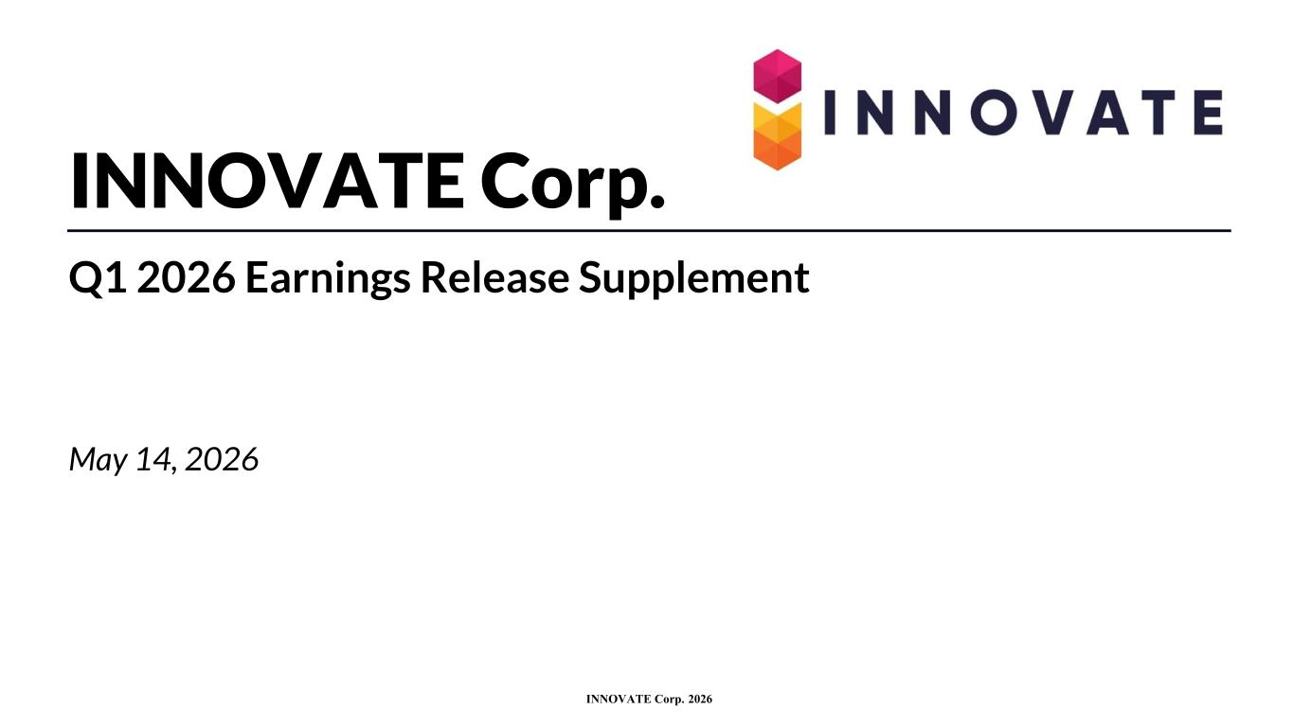
10
INNOVATE Corp. 2026 INNOVATE Corp. Q1 2026 Earnings Release Supplement May 14, 2026

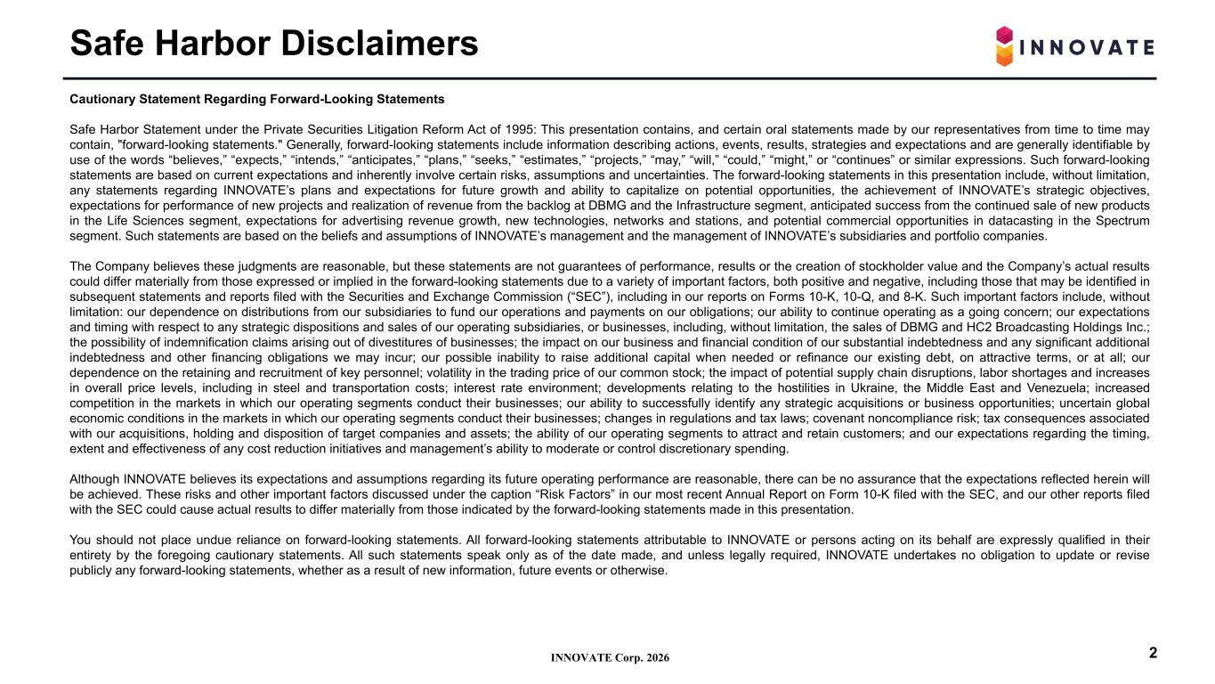
INNOVATE Corp. 2026 Safe Harbor Disclaimers 2 Cautionary Statement Regarding Forward-Looking Statements Safe Harbor Statement under the Private Securities Litigation Reform Act of 1995: This presentation contains, and certain oral statements made by our representatives from time to time may contain, "forward-looking statements." Generally, forward-looking statements include information describing actions, events, results, strategies and expectations and are generally identifiable by use of the words “believes,” “expects,” “intends,” “anticipates,” “plans,” “seeks,” “estimates,” “projects,” “may,” “will,” “could,” “might,” or “continues” or similar expressions. Such forward-looking statements are based on current expectations and inherently involve certain risks, assumptions and uncertainties. The forward-looking statements in this presentation include, without limitation, any statements regarding INNOVATE’s plans and expectations for future growth and ability to capitalize on potential opportunities, the achievement of INNOVATE’s strategic objectives, expectations for performance of new projects and realization of revenue from the backlog at DBMG and the Infrastructure segment, anticipated success from the continued sale of new products in the Life Sciences segment, expectations for advertising revenue growth, new technologies, networks and stations, and potential commercial opportunities in datacasting in the Spectrum segment. Such statements are based on the beliefs and assumptions of INNOVATE’s management and the management of INNOVATE’s subsidiaries and portfolio companies. The Company believes these judgments are reasonable, but these statements are not guarantees of performance, results or the creation of stockholder value and the Company’s actual results could differ materially from those expressed or implied in the forward-looking statements due to a variety of important factors, both positive and negative, including those that may be identified in subsequent statements and reports filed with the Securities and Exchange Commission (“SEC”), including in our reports on Forms 10-K, 10-Q, and 8-K. Such important factors include, without limitation: our dependence on distributions from our subsidiaries to fund our operations and payments on our obligations; our ability to continue operating as a going concern; our expectations and timing with respect to any strategic dispositions and sales of our operating subsidiaries, or businesses, including, without limitation, the sales of DBMG and HC2 Broadcasting Holdings Inc.; the possibility of indemnification claims arising out of divestitures of businesses; the impact on our business and financial condition of our substantial indebtedness and any significant additional indebtedness and other financing obligations we may incur; our possible inability to raise additional capital when needed or refinance our existing debt, on attractive terms, or at all; our dependence on the retaining and recruitment of key personnel; volatility in the trading price of our common stock; the impact of potential supply chain disruptions, labor shortages and increases in overall price levels, including in steel and transportation costs; interest rate environment; developments relating to the hostilities in Ukraine, the Middle East and Venezuela; increased competition in the markets in which our operating segments conduct their businesses; our ability to successfully identify any strategic acquisitions or business opportunities; uncertain global economic conditions in the markets in which our operating segments conduct their businesses; changes in regulations and tax laws; covenant noncompliance risk; tax consequences associated with our acquisitions, holding and disposition of target companies and assets; the ability of our operating segments to attract and retain customers; and our expectations regarding the timing, extent and effectiveness of any cost reduction initiatives and management’s ability to moderate or control discretionary spending. Although INNOVATE believes its expectations and assumptions regarding its future operating performance are reasonable, there can be no assurance that the expectations reflected herein will be achieved. These risks and other important factors discussed under the caption “Risk Factors” in our most recent Annual Report on Form 10-K filed with the SEC, and our other reports filed with the SEC could cause actual results to differ materially from those indicated by the forward-looking statements made in this presentation. You should not place undue reliance on forward-looking statements. All forward-looking statements attributable to INNOVATE or persons acting on its behalf are expressly qualified in their entirety by the foregoing cautionary statements. All such statements speak only as of the date made, and unless legally required, INNOVATE undertakes no obligation to update or revise publicly any forward-looking statements, whether as a result of new information, future events or otherwise.

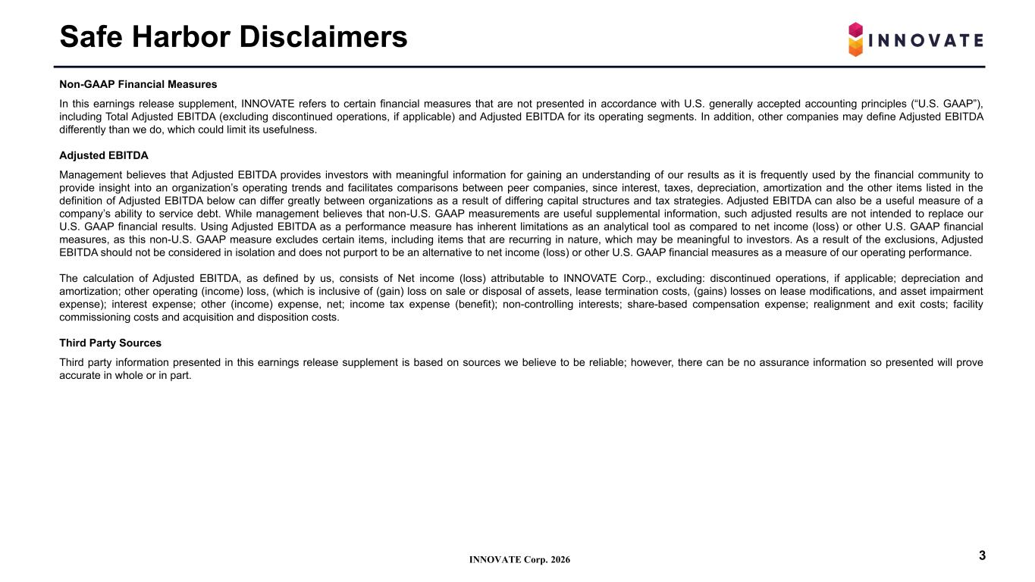
INNOVATE Corp. 2026 Safe Harbor Disclaimers 3 Non-GAAP Financial Measures In this earnings release supplement, INNOVATE refers to certain financial measures that are not presented in accordance with U.S. generally accepted accounting principles (“U.S. GAAP”), including Total Adjusted EBITDA (excluding discontinued operations, if applicable) and Adjusted EBITDA for its operating segments. In addition, other companies may define Adjusted EBITDA differently than we do, which could limit its usefulness. Adjusted EBITDA Management believes that Adjusted EBITDA provides investors with meaningful information for gaining an understanding of our results as it is frequently used by the financial community to provide insight into an organization’s operating trends and facilitates comparisons between peer companies, since interest, taxes, depreciation, amortization and the other items listed in the definition of Adjusted EBITDA below can differ greatly between organizations as a result of differing capital structures and tax strategies. Adjusted EBITDA can also be a useful measure of a company’s ability to service debt. While management believes that non-U.S. GAAP measurements are useful supplemental information, such adjusted results are not intended to replace our U.S. GAAP financial results. Using Adjusted EBITDA as a performance measure has inherent limitations as an analytical tool as compared to net income (loss) or other U.S. GAAP financial measures, as this non-U.S. GAAP measure excludes certain items, including items that are recurring in nature, which may be meaningful to investors. As a result of the exclusions, Adjusted EBITDA should not be considered in isolation and does not purport to be an alternative to net income (loss) or other U.S. GAAP financial measures as a measure of our operating performance. The calculation of Adjusted EBITDA, as defined by us, consists of Net income (loss) attributable to INNOVATE Corp., excluding: discontinued operations, if applicable; depreciation and amortization; other operating (income) loss, (which is inclusive of (gain) loss on sale or disposal of assets, lease termination costs, (gains) losses on lease modifications, and asset impairment expense); interest expense; other (income) expense, net; income tax expense (benefit); non-controlling interests; share-based compensation expense; realignment and exit costs; facility commissioning costs and acquisition and disposition costs. Third Party Sources Third party information presented in this earnings release supplement is based on sources we believe to be reliable; however, there can be no assurance information so presented will prove accurate in whole or in part.

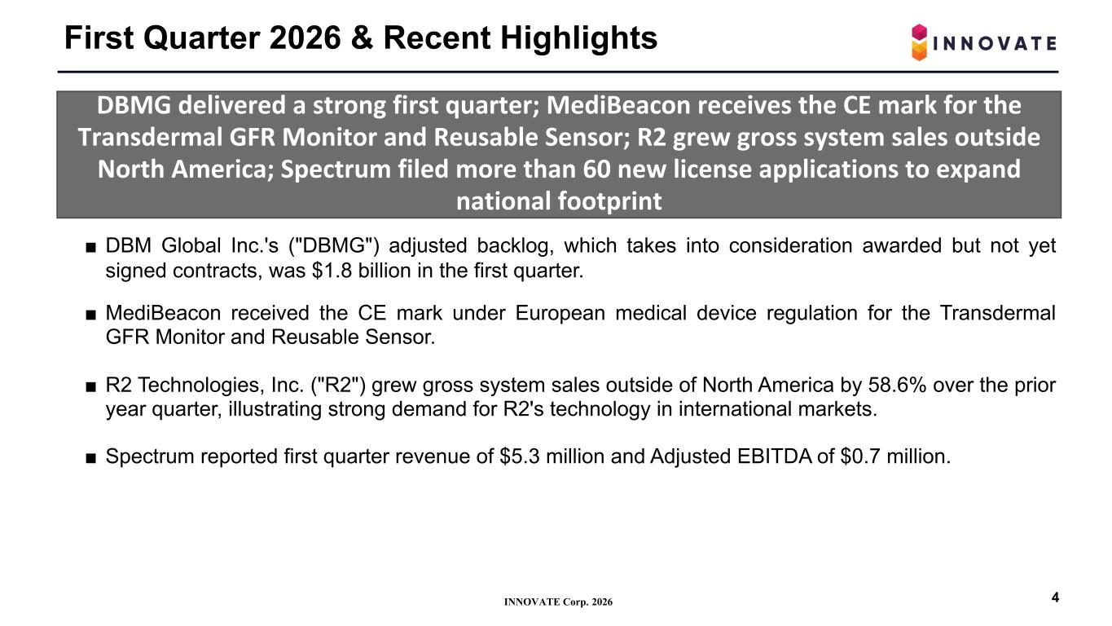
INNOVATE Corp. 2026 First Quarter 2026 & Recent Highlights 4 DBMG delivered a strong first quarter; MediBeacon receives the CE mark for the Transdermal GFR Monitor and Reusable Sensor; R2 grew gross system sales outside North America; Spectrum filed more than 60 new license applications to expand national footprint ■ DBM Global Inc.'s ("DBMG") adjusted backlog, which takes into consideration awarded but not yet signed contracts, was $1.8 billion in the first quarter. ■ MediBeacon received the CE mark under European medical device regulation for the Transdermal GFR Monitor and Reusable Sensor. ■ R2 Technologies, Inc. ("R2") grew gross system sales outside of North America by 58.6% over the prior year quarter, illustrating strong demand for R2's technology in international markets. ■ Spectrum reported first quarter revenue of $5.3 million and Adjusted EBITDA of $0.7 million.

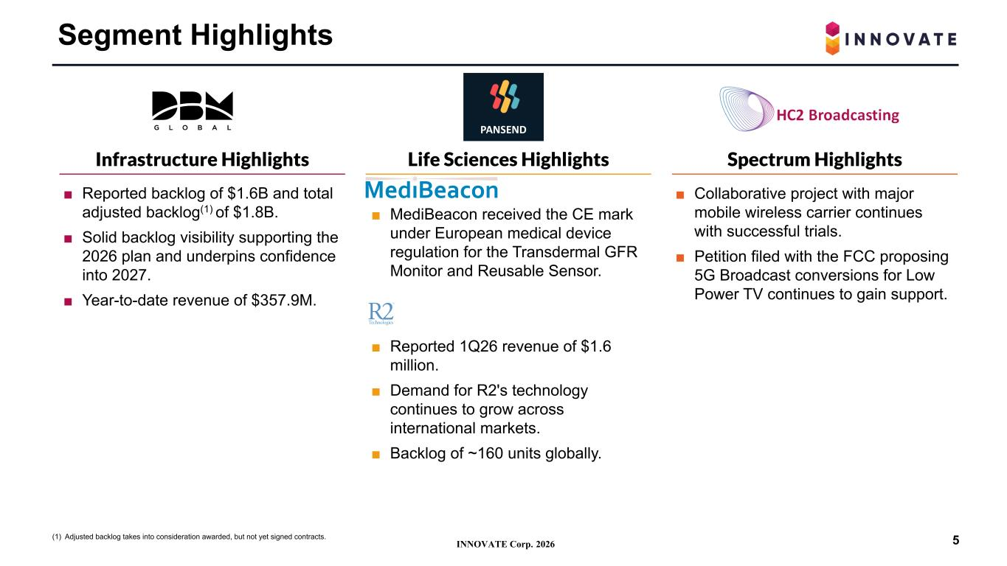
INNOVATE Corp. 2026 ■ MediBeacon received the CE mark under European medical device regulation for the Transdermal GFR Monitor and Reusable Sensor. ■ Reported 1Q26 revenue of $1.6 million. ■ Demand for R2's technology continues to grow across international markets. ■ Backlog of ~160 units globally. ■ Reported backlog of $1.6B and total adjusted backlog(1) of $1.8B. ■ Solid backlog visibility supporting the 2026 plan and underpins confidence into 2027. ■ Year-to-date revenue of $357.9M. Segment Highlights Infrastructure Highlights Life Sciences Highlights Spectrum Highlights 5(1) Adjusted backlog takes into consideration awarded, but not yet signed contracts. ■ Collaborative project with major mobile wireless carrier continues with successful trials. ■ Petition filed with the FCC proposing 5G Broadcast conversions for Low Power TV continues to gain support.

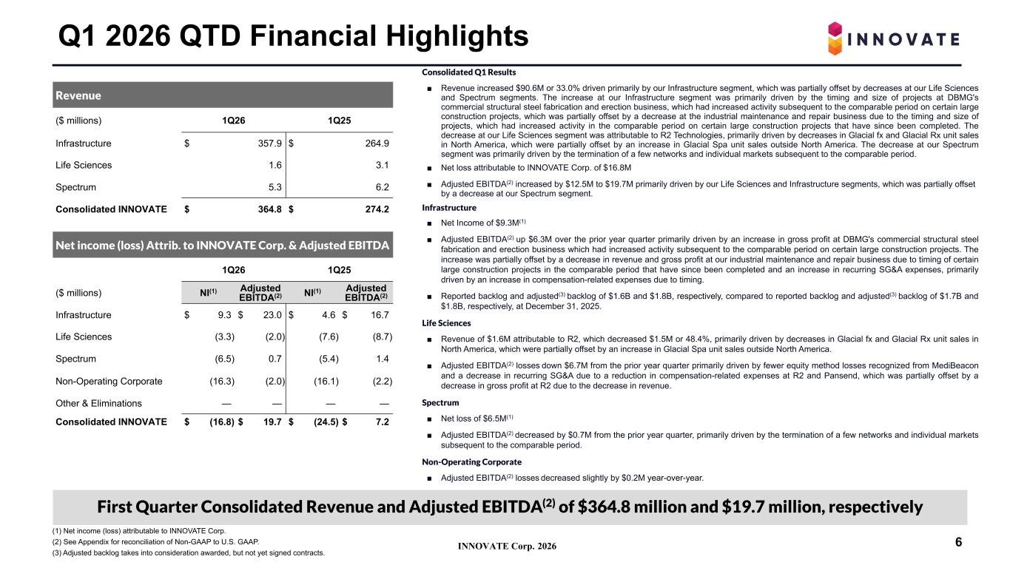
INNOVATE Corp. 2026 Consolidated Q1 Results ■ Revenue increased $90.6M or 33.0% driven primarily by our Infrastructure segment, which was partially offset by decreases at our Life Sciences and Spectrum segments. The increase at our Infrastructure segment was primarily driven by the timing and size of projects at DBMG's commercial structural steel fabrication and erection business, which had increased activity subsequent to the comparable period on certain large construction projects, which was partially offset by a decrease at the industrial maintenance and repair business due to the timing and size of projects, which had increased activity in the comparable period on certain large construction projects that have since been completed. The decrease at our Life Sciences segment was attributable to R2 Technologies, primarily driven by decreases in Glacial fx and Glacial Rx unit sales in North America, which were partially offset by an increase in Glacial Spa unit sales outside North America. The decrease at our Spectrum segment was primarily driven by the termination of a few networks and individual markets subsequent to the comparable period. ■ Net loss attributable to INNOVATE Corp. of $16.8M ■ Adjusted EBITDA(2) increased by $12.5M to $19.7M primarily driven by our Life Sciences and Infrastructure segments, which was partially offset by a decrease at our Spectrum segment. Infrastructure ■ Net Income of $9.3M(1) ■ Adjusted EBITDA(2) up $6.3M over the prior year quarter primarily driven by an increase in gross profit at DBMG's commercial structural steel fabrication and erection business which had increased activity subsequent to the comparable period on certain large construction projects. The increase was partially offset by a decrease in revenue and gross profit at our industrial maintenance and repair business due to timing of certain large construction projects in the comparable period that have since been completed and an increase in recurring SG&A expenses, primarily driven by an increase in compensation-related expenses due to timing. ■ Reported backlog and adjusted(3) backlog of $1.6B and $1.8B, respectively, compared to reported backlog and adjusted(3) backlog of $1.7B and $1.8B, respectively, at December 31, 2025. Life Sciences ■ Revenue of $1.6M attributable to R2, which decreased $1.5M or 48.4%, primarily driven by decreases in Glacial fx and Glacial Rx unit sales in North America, which were partially offset by an increase in Glacial Spa unit sales outside North America. ■ Adjusted EBITDA(2) losses down $6.7M from the prior year quarter primarily driven by fewer equity method losses recognized from MediBeacon and a decrease in recurring SG&A due to a reduction in compensation-related expenses at R2 and Pansend, which was partially offset by a decrease in gross profit at R2 due to the decrease in revenue. Spectrum ■ Net loss of $6.5M(1) ■ Adjusted EBITDA(2) decreased by $0.7M from the prior year quarter, primarily driven by the termination of a few networks and individual markets subsequent to the comparable period. Non-Operating Corporate ■ Adjusted EBITDA(2) losses decreased slightly by $0.2M year-over-year. Q1 2026 QTD Financial Highlights Revenue ($ millions) 1Q26 1Q25 Infrastructure $ 357.9 $ 264.9 Life Sciences 1.6 3.1 Spectrum 5.3 6.2 Consolidated INNOVATE $ 364.8 $ 274.2 Net income (loss) Attrib. to INNOVATE Corp. & Adjusted EBITDA 1Q26 1Q25 ($ millions) NI(1) Adjusted EBITDA(2) NI(1) Adjusted EBITDA(2) Infrastructure $ 9.3 $ 23.0 $ 4.6 $ 16.7 Life Sciences (3.3) (2.0) (7.6) (8.7) Spectrum (6.5) 0.7 (5.4) 1.4 Non-Operating Corporate (16.3) (2.0) (16.1) (2.2) Other & Eliminations — — — — Consolidated INNOVATE $ (16.8) $ 19.7 $ (24.5) $ 7.2 (1) Net income (loss) attributable to INNOVATE Corp. (2) See Appendix for reconciliation of Non-GAAP to U.S. GAAP. (3) Adjusted backlog takes into consideration awarded, but not yet signed contracts. 6 First Quarter Consolidated Revenue and Adjusted EBITDA(2) of $364.8 million and $19.7 million, respectively

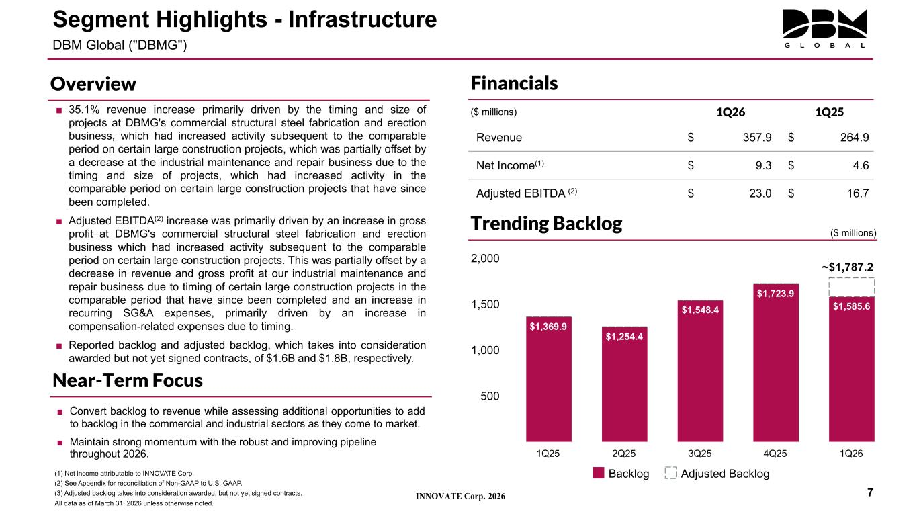
INNOVATE Corp. 2026 ■ 35.1% revenue increase primarily driven by the timing and size of projects at DBMG's commercial structural steel fabrication and erection business, which had increased activity subsequent to the comparable period on certain large construction projects, which was partially offset by a decrease at the industrial maintenance and repair business due to the timing and size of projects, which had increased activity in the comparable period on certain large construction projects that have since been completed. ■ Adjusted EBITDA(2) increase was primarily driven by an increase in gross profit at DBMG's commercial structural steel fabrication and erection business which had increased activity subsequent to the comparable period on certain large construction projects. This was partially offset by a decrease in revenue and gross profit at our industrial maintenance and repair business due to timing of certain large construction projects in the comparable period that have since been completed and an increase in recurring SG&A expenses, primarily driven by an increase in compensation-related expenses due to timing. ■ Reported backlog and adjusted backlog, which takes into consideration awarded but not yet signed contracts, of $1.6B and $1.8B, respectively. Financials ($ millions) 1Q26 1Q25 Revenue $ 357.9 $ 264.9 Net Income(1) $ 9.3 $ 4.6 Adjusted EBITDA (2) $ 23.0 $ 16.7 (1) Net income attributable to INNOVATE Corp. (2) See Appendix for reconciliation of Non-GAAP to U.S. GAAP. (3) Adjusted backlog takes into consideration awarded, but not yet signed contracts. All data as of March 31, 2026 unless otherwise noted. Segment Highlights - Infrastructure DBM Global ("DBMG") 7 $1,369.9 $1,254.4 $1,548.4 $1,723.9 $1,585.6 Backlog Adjusted Backlog 1Q25 2Q25 3Q25 4Q25 1Q26 500 1,000 1,500 2,000 ~$1,787.2 Trending Backlog Overview Near-Term Focus ($ millions) ■ Convert backlog to revenue while assessing additional opportunities to add to backlog in the commercial and industrial sectors as they come to market. ■ Maintain strong momentum with the robust and improving pipeline throughout 2026.

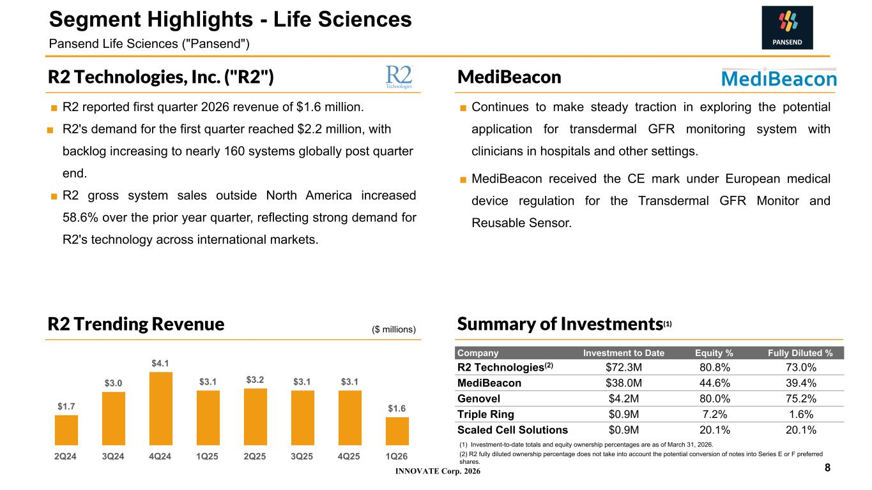
INNOVATE Corp. 2026 ■ Continues to make steady traction in exploring the potential application for transdermal GFR monitoring system with clinicians in hospitals and other settings. ■ MediBeacon received the CE mark under European medical device regulation for the Transdermal GFR Monitor and Reusable Sensor. ■ R2 reported first quarter 2026 revenue of $1.6 million. ■ R2's demand for the first quarter reached $2.2 million, with backlog increasing to nearly 160 systems globally post quarter end. ■ R2 gross system sales outside North America increased 58.6% over the prior year quarter, reflecting strong demand for R2's technology across international markets. MediBeaconR2 Technologies, Inc. ("R2") (1) Investment-to-date totals and equity ownership percentages are as of March 31, 2026. (2) R2 fully diluted ownership percentage does not take into account the potential conversion of notes into Series E or F preferred shares. Company Investment to Date Equity % Fully Diluted % R2 Technologies(2) $72.3M 80.8% 73.0% MediBeacon $38.0M 44.6% 39.4% Genovel $4.2M 80.0% 75.2% Triple Ring $0.9M 7.2% 1.6% Scaled Cell Solutions $0.9M 20.1% 20.1% 8 Segment Highlights - Life Sciences Pansend Life Sciences ("Pansend") Summary of Investments(1) $1.7 $3.0 $4.1 $3.1 $3.2 $3.1 $3.1 $1.6 2Q24 3Q24 4Q24 1Q25 2Q25 3Q25 4Q25 1Q26 R2 Trending Revenue ($ millions)

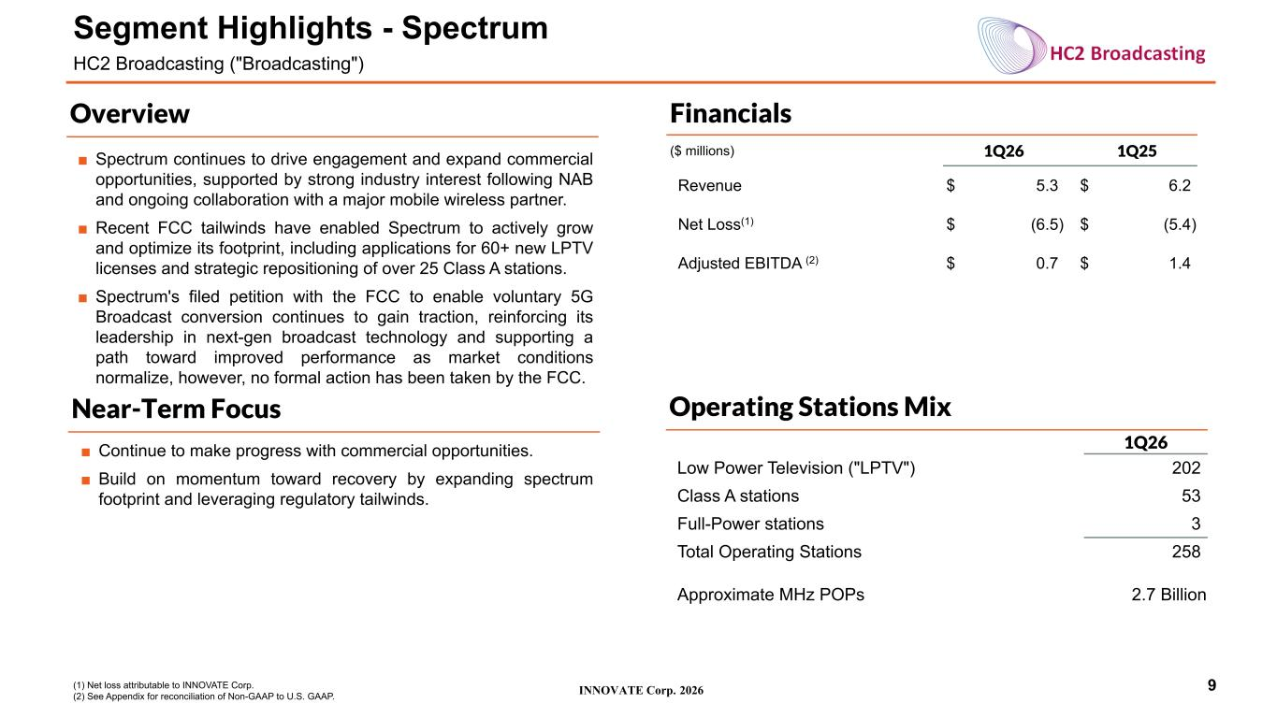
INNOVATE Corp. 2026 Financials ($ millions) 1Q26 1Q25 Revenue $ 5.3 $ 6.2 Net Loss(1) $ (6.5) $ (5.4) Adjusted EBITDA (2) $ 0.7 $ 1.4 9 Segment Highlights - Spectrum HC2 Broadcasting ("Broadcasting") Overview Near-Term Focus (1) Net loss attributable to INNOVATE Corp. (2) See Appendix for reconciliation of Non-GAAP to U.S. GAAP. Operating Stations Mix 1Q26 Low Power Television ("LPTV") 202 Class A stations 53 Full-Power stations 3 Total Operating Stations 258 Approximate MHz POPs 2.7 Billion ■ Spectrum continues to drive engagement and expand commercial opportunities, supported by strong industry interest following NAB and ongoing collaboration with a major mobile wireless partner. ■ Recent FCC tailwinds have enabled Spectrum to actively grow and optimize its footprint, including applications for 60+ new LPTV licenses and strategic repositioning of over 25 Class A stations. ■ Spectrum's filed petition with the FCC to enable voluntary 5G Broadcast conversion continues to gain traction, reinforcing its leadership in next-gen broadcast technology and supporting a path toward improved performance as market conditions normalize, however, no formal action has been taken by the FCC. ■ Continue to make progress with commercial opportunities. ■ Build on momentum toward recovery by expanding spectrum footprint and leveraging regulatory tailwinds.

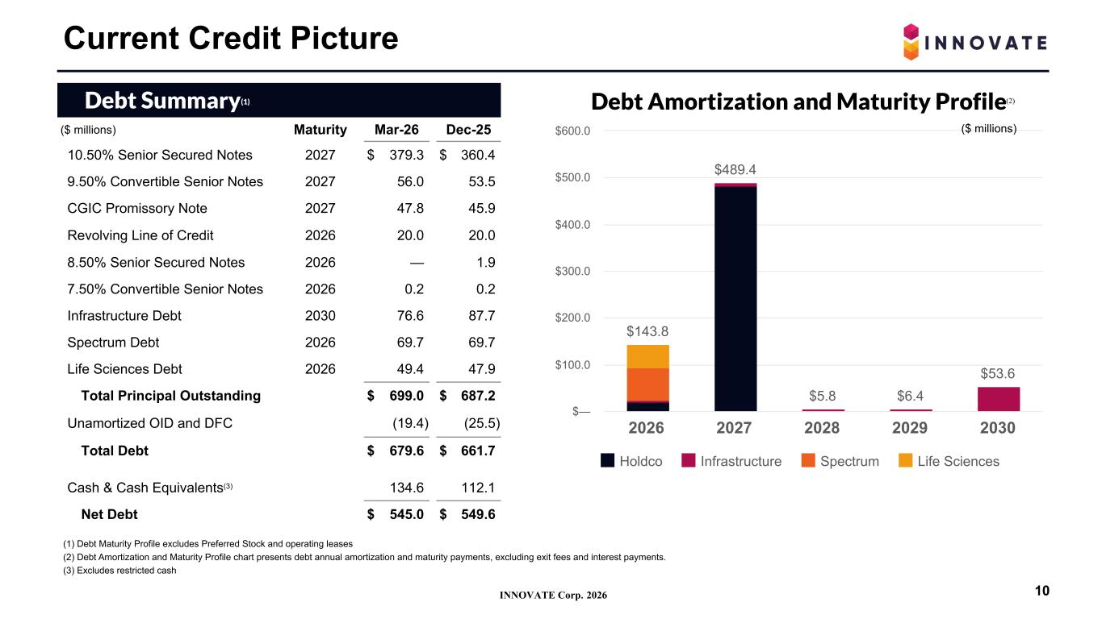
INNOVATE Corp. 2026 (1) Debt Maturity Profile excludes Preferred Stock and operating leases (2) Debt Amortization and Maturity Profile chart presents debt annual amortization and maturity payments, excluding exit fees and interest payments. (3) Excludes restricted cash Debt Summary(1) ($ millions) Maturity Mar-26 Dec-25 10.50% Senior Secured Notes 2027 $ 379.3 $ 360.4 9.50% Convertible Senior Notes 2027 56.0 53.5 CGIC Promissory Note 2027 47.8 45.9 Revolving Line of Credit 2026 20.0 20.0 8.50% Senior Secured Notes 2026 — 1.9 7.50% Convertible Senior Notes 2026 0.2 0.2 Infrastructure Debt 2030 76.6 87.7 Spectrum Debt 2026 69.7 69.7 Life Sciences Debt 2026 49.4 47.9 Total Principal Outstanding $ 699.0 $ 687.2 Unamortized OID and DFC (19.4) (25.5) Total Debt $ 679.6 $ 661.7 Cash & Cash Equivalents(3) 134.6 112.1 Net Debt $ 545.0 $ 549.6 Current Credit Picture 10 Debt Amortization and Maturity Profile $143.8 $489.4 $5.8 $6.4 $53.6 Holdco Infrastructure Spectrum Life Sciences 2026 2027 2028 2029 2030 $— $100.0 $200.0 $300.0 $400.0 $500.0 $600.0 ($ millions) (2)

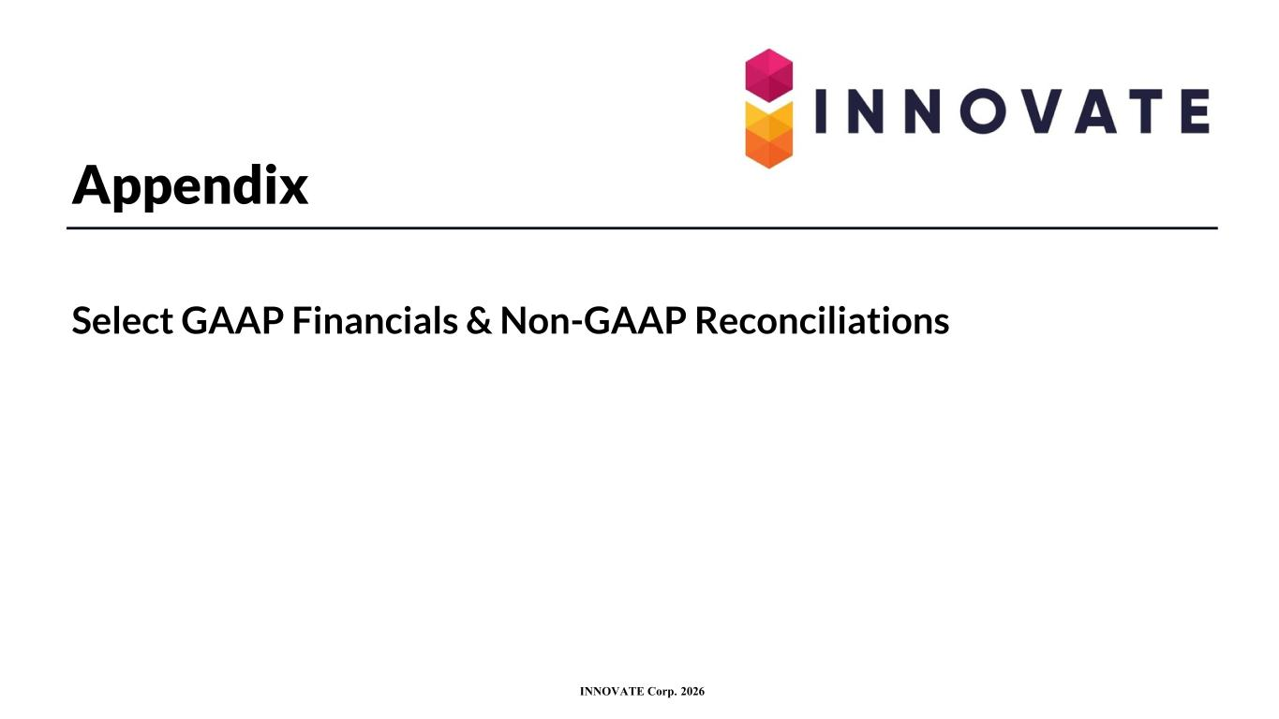
INNOVATE Corp. 2026 Appendix Select GAAP Financials & Non-GAAP Reconciliations

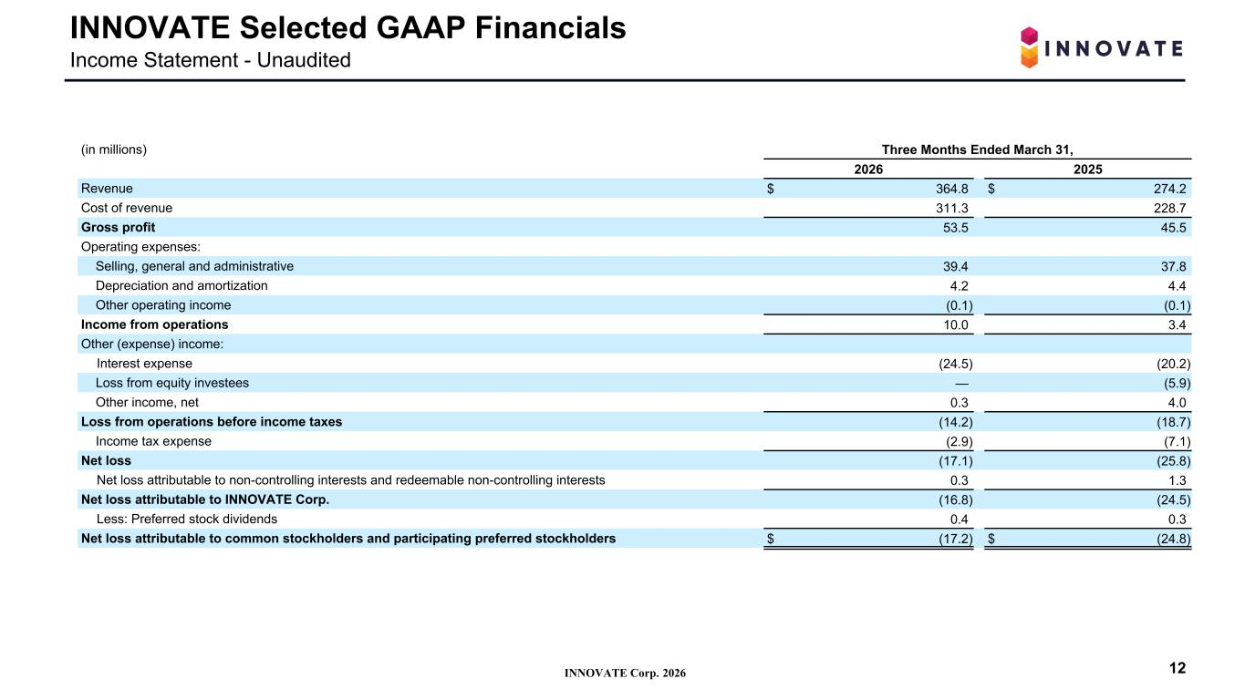
INNOVATE Corp. 2026 INNOVATE Selected GAAP Financials Income Statement - Unaudited (in millions) Three Months Ended March 31, 2026 2025 Revenue $ 364.8 $ 274.2 Cost of revenue 311.3 228.7 Gross profit 53.5 45.5 Operating expenses: Selling, general and administrative 39.4 37.8 Depreciation and amortization 4.2 4.4 Other operating income (0.1) (0.1) Income from operations 10.0 3.4 Other (expense) income: Interest expense (24.5) (20.2) Loss from equity investees — (5.9) Other income, net 0.3 4.0 Loss from operations before income taxes (14.2) (18.7) Income tax expense (2.9) (7.1) Net loss (17.1) (25.8) Net loss attributable to non-controlling interests and redeemable non-controlling interests 0.3 1.3 Net loss attributable to INNOVATE Corp. (16.8) (24.5) Less: Preferred stock dividends 0.4 0.3 Net loss attributable to common stockholders and participating preferred stockholders $ (17.2) $ (24.8) 12

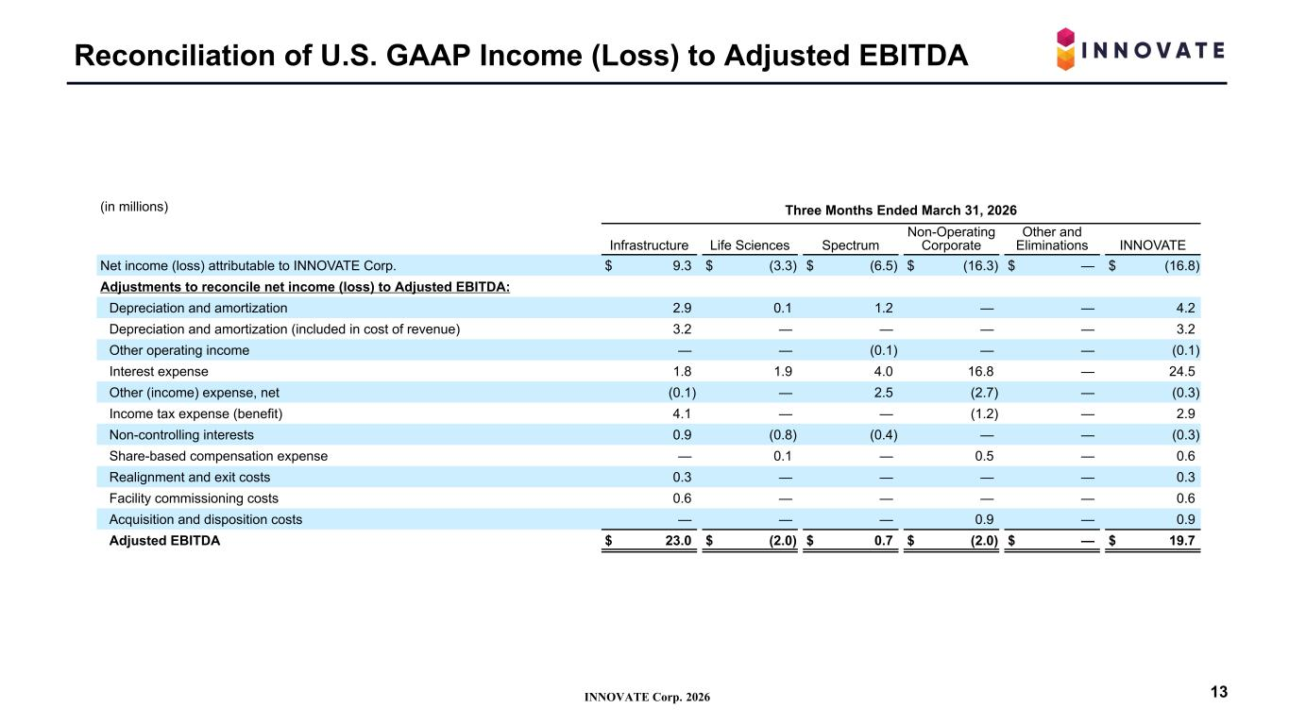
INNOVATE Corp. 2026 Reconciliation of U.S. GAAP Income (Loss) to Adjusted EBITDA 13 (in millions) Three Months Ended March 31, 2026 Infrastructure Life Sciences Spectrum Non-Operating Corporate Other and Eliminations INNOVATE Net income (loss) attributable to INNOVATE Corp. $ 9.3 $ (3.3) $ (6.5) $ (16.3) $ — $ (16.8) Adjustments to reconcile net income (loss) to Adjusted EBITDA: Depreciation and amortization 2.9 0.1 1.2 — — 4.2 Depreciation and amortization (included in cost of revenue) 3.2 — — — — 3.2 Other operating income — — (0.1) — — (0.1) Interest expense 1.8 1.9 4.0 16.8 — 24.5 Other (income) expense, net (0.1) — 2.5 (2.7) — (0.3) Income tax expense (benefit) 4.1 — — (1.2) — 2.9 Non-controlling interests 0.9 (0.8) (0.4) — — (0.3) Share-based compensation expense — 0.1 — 0.5 — 0.6 Realignment and exit costs 0.3 — — — — 0.3 Facility commissioning costs 0.6 — — — — 0.6 Acquisition and disposition costs — — — 0.9 — 0.9 Adjusted EBITDA $ 23.0 $ (2.0) $ 0.7 $ (2.0) $ — $ 19.7

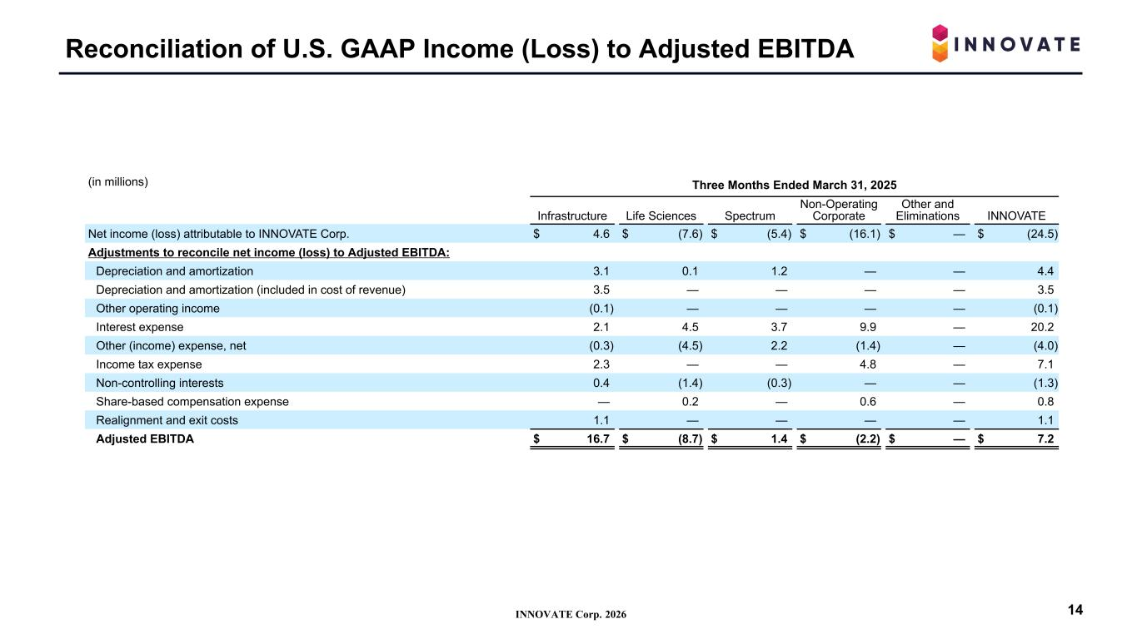
INNOVATE Corp. 2026 Reconciliation of U.S. GAAP Income (Loss) to Adjusted EBITDA 14 (in millions) Three Months Ended March 31, 2025 Infrastructure Life Sciences Spectrum Non-Operating Corporate Other and Eliminations INNOVATE Net income (loss) attributable to INNOVATE Corp. $ 4.6 $ (7.6) $ (5.4) $ (16.1) $ — $ (24.5) Adjustments to reconcile net income (loss) to Adjusted EBITDA: Depreciation and amortization 3.1 0.1 1.2 — — 4.4 Depreciation and amortization (included in cost of revenue) 3.5 — — — — 3.5 Other operating income (0.1) — — — — (0.1) Interest expense 2.1 4.5 3.7 9.9 — 20.2 Other (income) expense, net (0.3) (4.5) 2.2 (1.4) — (4.0) Income tax expense 2.3 — — 4.8 — 7.1 Non-controlling interests 0.4 (1.4) (0.3) — — (1.3) Share-based compensation expense — 0.2 — 0.6 — 0.8 Realignment and exit costs 1.1 — — — — 1.1 Adjusted EBITDA $ 16.7 $ (8.7) $ 1.4 $ (2.2) $ — $ 7.2

